Translation” of 2-3 selected labs from Console instructions to 100% command line instructions.

**Google Cloud Fundamentals: Getting Started with Compute Engine**

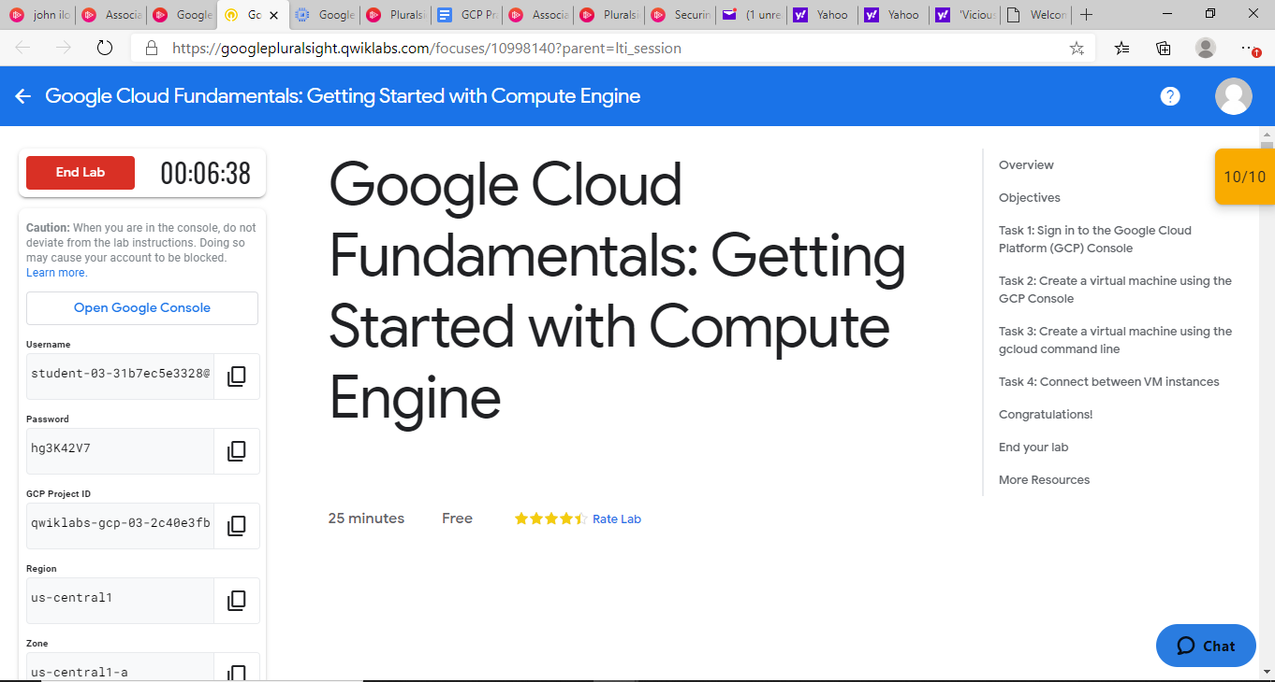

1. Create a Compute Engine virtual machine named my-vm-1 using the Command line on GCP Project ID qwiklabs-gcp-03-2c40e3fbd9a5 in us-central1-a zone

click the Open Cloud Shell button.

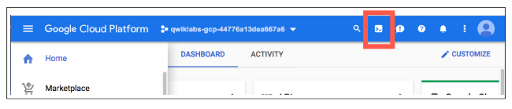

* At the command prompt type

# gcloud compute --project=qwiklabs-gcp-03-2c40e3fbd9a5 instances create my-vm-1 \

--zone=us-central1-a --machine-type=e2-medium --subnet=default --network-tier=PREMIUM

* Then add the required firewall rules by using the command below:

# gcloud compute --project=qwiklabs-gcp-03-2c40e3fbd9a5 firewall-rules create default-allow-http \

--direction=INGRESS --priority=1000 --network=default --action=ALLOW \

--rules=tcp:80 --source-ranges=0.0.0.0/0 --target-tags=http-server

1. Create a Compute Engine virtual machine using the gcloud command-line interface.

* Create the second VM named **my-vm-2**using the command detailed below:

# gcloud compute instances create "my-vm-2" \

-–zone us-central1-a \

--machine-type "n1-standard-1" \

--image-project "debian-cloud" \

--image "debian-9-stretch-v20190213" \

--subnet "default"

1. Connect between the two instances.

* In the **Navigation menu** (), click **Compute Engine > VM instances**
* To open a command prompt on the **my-vm-2** instance, click **SSH** of **my-vm-2**

At the prompt of **my-vm-2** ping the **my-vm-1**

#ping -c 3 **my-vm-1**

* **SSH to my-vm-1 from my-vm-2 prompt.**

#ssh my-vm-1

* At the command prompt on my-vm-1, install the Nginx web server:

#sudo apt-get install nginx-light -y

* Use the nano text editor to add a custom message to the home page of the web server:

sudo nano /var/www/html/index.nginx-debian.html

* Use the arrow keys to move the cursor to the line just below the h1 header. Add text like this:

Hi from John Ilozor

* Press Ctrl+O and then press Enter to save your edited file, and then press Ctrl+X to exit the nano text editor.
* Confirm that the web server is serving your new page. At the command prompt on my-vm-1, execute this command:

#curl http://localhost/

* To exit the command prompt on my-vm-1, execute this command:

#exit

* To confirm that my-vm-2 can reach the web server on my-vm-1, at the command prompt on my-vm-2, execute this command:

#curl http://my-vm-1/

Google Cloud Fundamentals: Getting Started with Cloud Storage and Cloud SQL